**RESULTS**

Total number of three hundred (300) self-administered questionnaires was distributed to health workers in the study area. The instruments were thoroughly checked for completeness and consistency. However, only two hundred and ninety-five (295) questionnaires were able to recover and these were subjected to statistical analysis as shown below.

**4.1 SOCIO-DEMOGRAPHIC CHARACTERISTICS OF THE RESPONDENTS**

As shown on Table 1;

Majority of the respondents were within the age of 30-39 years (44.41%), followed by those within the age of 18-29 years (25.08%), 40-49 years (20.68) and few were 50 years and above (9.83%).

More than half of the respondents were male (51.19%) and the rest were female (48.81%).

Based on the marital status, most of the respondents were married (62.37%), followed by those that were single (24.41%), divorced (7.12%) and Widow/Widower (6.1%).

Majority of the respondents were Yoruba (58.98%), followed by Hausa (15.93%), Igbo (10.85%), Other ethnic groups (7.46%) and Fulani (6.78%).

The religion of the respondents showed mostly practice Islam (59.11%), 39.52% practice Christianity and 1.37% practice other religion.

Majority of the respondents were Nurses (20.0%), followed by Pharmacist (14.58%), Health Information Workers (14.24%), Doctor (11.86%), Medical Laboratory Scientist (11.86%), Other professions (9.49%), Medical Laboratory Technicians (8.47%), Pharmacy technician (6.1%) and Dentist (3.39%)

Most of the respondents earn #31,000-#100,000 (52.54%), followed by those who earn above #100,000 (32.54%), 10.51% earn between #18,000-#30,000 and few less than #18,000 (4.41%)

More than half of the respondents leave in Urban area (61.02%) and the remaining reside in Rural area (38.98%)

**4.2 UPTAKE OF COVID-19 VACCINE BOOSTER DOSE**

As shown on Table 2; majority (53.02%) of respondents have taken COVID-19 vaccine booster dose while 46.98% are yet to take the booster dose

**4.3 ATTITUDE OF RESPONDENTS TOWARDS COVID-19 VACCINE BOOSTER DOSE**

As shown on Table 3; more than half (69.49%) of the respondents had good attitude towards COVID-19 vaccine booster dose and 30.51% had poor attitude towards COVID-19 vaccine booster dose.

**4.4 TEST OF HYPOTHESIS**

As shown on Table 4;

There was statistically significance association between age (p=0.003), marital status (p=0.014), religion (p=0.045), income (p=0.003) and uptake of covid-19 vaccine booster dose at p<0.05.

There was no statistically significant association between gender, ethnicity, level of education, location and uptake of covid-19 vaccine booster dose at p>0.05.

There was statistically significance association between attitude towards Covid-19 vaccine booster dose (p=0.049) and uptake of covid-19 vaccine booster dose at p<0.05.

**Table 1: Socio-demographic characteristics of respondents**

|  |  |  |
| --- | --- | --- |
| Variable | Frequency (n=295) | Percentage (%) |
| Age |  |  |
| 18 – 29 | 74 | 25.08 |
| 30 -39 | 131 | 44.41 |
| 40 – 49 | 61 | 20.68 |
| 50 and above | 29 | 9.83 |
| Gender |  |  |
| Female | 144 | 48.81 |
| Male | 151 | 51.19 |
| Marital status | |  |
| Divorced | 21 | 7.12 |
| Married | 184 | 62.37 |
| Single | 72 | 24.41 |
| Widow/Widower | 18 | 6.1 |
| Ethnicity |  |  |
| Fulani | 20 | 6.78 |
| Hausa | 47 | 15.93 |
| Igbo | 32 | 10.85 |
| Others | 22 | 7.46 |
| Yoruba | 174 | 58.98 |
| Religion |  |  |
| Christianity | 115 | 39.52 |
| Islam | 172 | 59.11 |
| Others | 4 | 1.37 |
| Profession | |  |
| Dentist | 10 | 3.39 |
| Doctor | 35 | 11.86 |
| Health Information workers | 42 | 14.24 |
| Medical Laboratory Scientist/Technician | 35 | 11.86 |
| Medical Laboratory Technician | 25 | 8.47 |
| Nurse | 59 | 20 |
| Other | 28 | 9.49 |
| Pharmacist | 43 | 14.58 |
| Pharmacy technician | 18 | 6.1 |
| Income level | |  |
| 18,000 - 30,000 | 31 | 10.51 |
| 31,000 - 100,000 | 155 | 52.54 |
| Above 100,000 | 96 | 32.54 |
| Less than 18,000 | 13 | 4.41 |
| Location |  |  |
| Rural | 115 | 38.98 |
| Urban | 180 | 61.02 |

*Table 2 Uptake of covid-19 vaccine booster dose*

|  |  |  |
| --- | --- | --- |
| Have you taken covid-19 vaccine booster dose? | Frequency (n=281) | Percentage (%) |
| No | 132 | 46.98 |
| Yes | 149 | 53.02 |

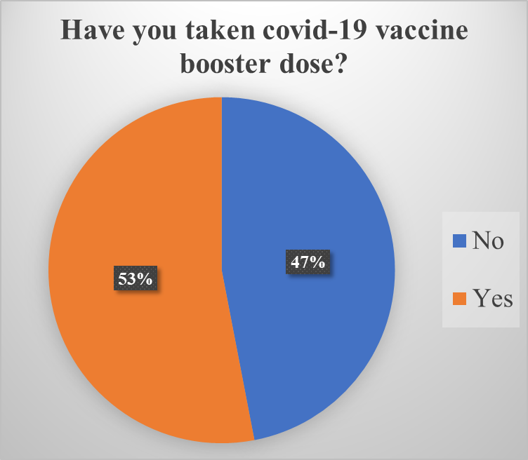

Figure 1 Chart showing the frequency distribution of Uptake of covid-19 vaccine booster dose among respondents

*Table 3 Attitude of respondents towards covid-19 vaccine booster dose*

|  |  |  |
| --- | --- | --- |
| Variable | Frequency (n=295) | Percentage (%) |
| Attitude |  |  |
| Good attitude | 205 | 69.49 |
| Poor attitude | 90 | 30.51 |

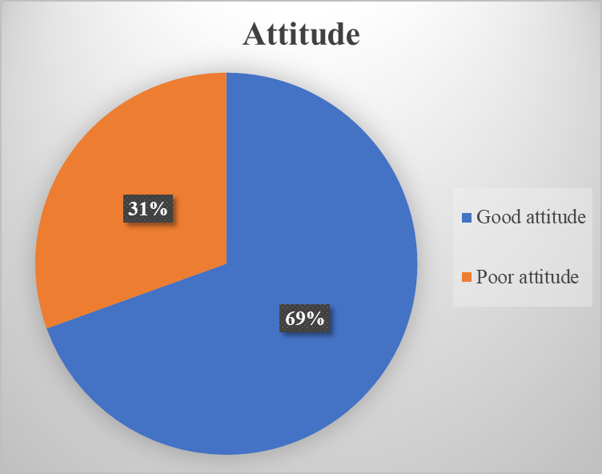

*Figure 2 Chart showing the attitude of respondents toward covid-19 vaccine booster dose*

Table 4 Chi square test for independence to determine the determinants of uptake of covid-19 vaccine booster dose using the socio-demographic characteristics as independent variables. (Level of significance set at p<=0.05)

|  |  |  |  |  |  |
| --- | --- | --- | --- | --- | --- |
| Variable | Poor uptake  Frequency(n=132)  Percentage(%) | Good uptake  Frequency(n=132)  Percentage(%) | Total  Frequency(n=132)  Percentage(%) | Chi2 value | p value |
| Age category | |  |  |  |  |
| 18 - 29 | 42 | 24 | 66 | 13.8854 | 0.003 |
| 31.82 | 16.11 | 23.49 |
| 30 -39 | 56 | 71 | 127 |
| 42.42 | 47.65 | 45.2 |
| 40 - 49 | 27 | 32 | 59 |
| 20.45 | 21.48 | 21 |
| 50 and above | 7 | 22 | 29 |
| 5.3 | 14.77 | 10.32 |
| Gender |  |  |  |  |  |
| Female | 61 | 73 | 134 | 0.217 | 0.641 |
| 46.21 | 48.99 | 47.69 |
| Male | 71 | 76 | 147 |
| 53.79 | 51.01 | 52.3 |
| Marital status | |  |  |  |  |
| Divorced | 10 | 11 | 21 | 10.6928 | 0.014 |
| 7.58 | 7.38 | 7.47 |
| Married | 77 | 102 | 179 |
| 58.33 | 68.46 | 63.7 |
| Single | 40 | 23 | 63 |
| 30.3 | 15.44 | 22.42 |
| Widow/Widower | 5 | 13 | 18 |
| 3.79 | 8.72 | 6.41 |
| Ethnicity |  |  |  |  |  |
| Fulani | 10 | 8 | 18 | 3.9229 | 0.417 |
| 7.58 | 5.37 | 6.41 |
| Hausa | 22 | 23 | 45 |
| 16.67 | 15.44 | 16.01 |
| Igbo | 16 | 15 | 31 |
| 12.12 | 10.07 | 11.03 |
| Others | 13 | 8 | 21 |
| 9.85 | 5.37 | 7.47 |
| Yoruba | 71 | 95 | 166 |
| 53.79 | 63.76 | 59.07 |
| Religion |  |  |  |  |  |
| Christianity | 44 | 63 | 107 | 6.1961 | 0.045 |
| 34.11 | 42.57 | 38.63 |
| Islam | 85 | 81 | 166 |
| 65.89 | 54.73 | 59.93 |
| Others | 0 | 4 | 4 |
| 0 | 2.7 | 1.44 |
| Level of education | |  |  |  |  |
| None | 6 | 4 | 10 | 5.6247 | 0.131 |
| 4.55 | 2.68 | 3.56 |
| Primary | 0 | 1 | 1 |
| 0 | 0.67 | 0.36 |
| Secondary | 9 | 3 | 12 |
| 6.82 | 2.01 | 4.27 |
| Tertiary | 117 | 141 | 258 |
| 88.64 | 94.63 | 91.81 |
| Income |  |  |  |  |  |
| 18,000 - 30,000 | 19 | 8 | 27 | 14.1141 | 0.003 |
| 14.39 | 5.37 | 9.61 |
| 31,000 - 100,000 | 71 | 76 | 147 |
| 53.79 | 51.01 | 52.31 |
| Above 100,000 | 34 | 62 | 96 |
| 25.76 | 41.61 | 34.16 |
| Less than 18,000 | 8 | 3 | 11 |
| 6.06 | 2.01 | 3.91 |
| Location |  |  |  |  |  |
| Rural | 54 | 54 | 108 | 0.6444 | 0.422 |
| 40.91 | 36.24 | 38.43 |
| Urban | 78 | 95 | 173 |
| 59.09 | 63.76 | 61.57 |
| Attitude |  |  |  |  |  |
| Good attitude | 84 | 111 | 195 | 3.887 | 0.049 |
| 63.64 | 74.5 | 69.4 |
| Poor attitude | 48 | 38 | 86 |
| 36.36 | 25.5 | 30.6 |

*Figure 3 Chart showing the attitude of respondents toward and uptake of covid-19 vaccine booster dose*